DNA methylation in breast cancer: towards precision medicine
Introduction
Breast cancer (BC) is a kind of solid tumour, the most common cancer in females, leading to 30% of female cancer cases and a significant health burden worldwide (Fan et al., 2014; Siegel et al., 2020). While genetic predisposition contributes to only about 10% of the cases (Lalloo & Evans, 2012), epigenetic factors, which alter gene function without changing DNA sequences, play a significant role (Pasculli et al., 2018). The reversibility of the factors may enable precision medicine, which can tailor therapies according to specific molecular bases in BC (Coleman, 2013).
DNA methylation is a major type of epigenetic change associated with oncogenesis (Easwaran & Baylin, 2019). The Cancer Genome Atlas (TCGA) has incorporated DNA methylation into its criteria for BC subtyping. In one subtype, there are reportedly 490 genes with hypermethylation, where the functional annotations vital to tumourigenesis, such as those of the “Wnt signalling pathway,” are altered (Koboldt et al., 2012). As the epigenetic diversity of BC implies different pathogenesis with different impacts on the treatment, precision medicine, which tailors therapies according to specific patient features (Pinker et al., 2018), should be used (Stefansson & Esteller, 2013; Pasculli et al., 2018).
There are three pillars for precision medicine based on DNA methylation, including 1) detection of DNA methylation and sequent analysis of pathogenesis, which enables patient stratification; 2) DNA methylation manipulation, which allows personalised therapies targeting DNA methylation; and 3) effective drug delivery platforms that ensure the therapies to work in the right place at the right time with the correct dosage. In this article, we will discuss these pillars in the context of BC.
Current State of Knowledge Pillar 1: DNA methylation detection
Detection of molecular changes is the basis of precision medicine (Jones et al., 2019), which may explain BC heterogeneity and enable drug choice optimisation. For example, BRCA1 promoter hypermethylation is related to breast tumorigenesis (Dobrovic & Simpfendorfer, 1997; Rice et al., 2000). Since the TGFβ/miR-182/BRCA1 axis regulates cell differentiation (Martinez-Ruiz et al., 2016), loss of BRCA1 function due to DNA methylation may cause poorly differentiated, basal-like tumour tissues with a weaker response to chemo-drug cisplatin (Silver et al., 2010). Therefore, detecting BRCA1 promoter hypermethylation may help us avoid using drugs with poor efficacy.
To detect DNA methylation, one must know the molecular basis of DNA methylation. Chemically speaking, DNA methylation, which adds a methyl group to DNA, can happen in adenine and cytosine. In contrast, in mammals, it rarely occurs in adenine and usually coverts cytosine into 5-methyl cytosine (5mC) in CpG islands, where there are high cytosine-guanine dinucleotide repeats (Kumar et al., 2018). Early studies used methylation-sensitive restriction enzymes and affinity-based methods like chromatography to discover oncogenic DNA methylation (Compere & Palmiter, 1981; Herman et al., 1994), whereas bisulfite conversion, which only changes unmethylated cytosine to uracil, has enabled fast and high throughput measurement of DNA methylation (Bhattacharjee et al., 2018).
Computational models assist in further exploration of how DNA methylation is associated with BC heterogeneity (Przybilla et al., 2014). For example, Tong et al. (2018) developed an algorithm using the TCGA dataset to investigate the causal effects on tumorigenesis of promoter methylation. Kim et al. (2018) proposed a pathway-based model to predict cancer survival with DNA methylation profiles. Apart from the 5 clusters of BC subtypes with different DNA methylation patterns defined by TCGA (Koboldt et al., 2012), there are also other proposed epigenetic-based subtypes (Table 1).
Pillar 2: DNA methylation manipulation
DNA methylation manipulation enables therapies targeting the aberrant methylation in BC. Knowledge of DNA methylation machinery is essential for DNA methylation manipulation. DNA methylation is sustained by DNA-Methyl Transferases (DNMT) (Deaton & Bird, 2011; Jones, 2012), whereas the demethylation pathways are regulated by TET enzymes (Reddington et al., 2014) (Figure 1). After DNMT3a and DNMT3b introduce methylation to specific sequences, especially CpG islands (Ravichandran et al., 2018), DNMT1 tends to methylate new CpG islands whose partners on the parental strand are already methylated, leading to the inheritance of DNA methylation during DNA replication (Bird, 2002). DNA methylation hinders PRC binding to chromatin and triggers H3K27me3 redistribution, both of which mediate gene suppression (Koboldt et al., 2012; Reddington et al., 2014).
These enzymes in methylation and demethylation processes are ideal targets for DNA methylation manipulation. To reverse DNA methylation, the first approach is the manipulation of DNMT (Miranda Furtado et al., 2019), which is usually dysregulated in BC (Zhang & Xu, 2017). For example, Tang et al. (2014) used ectopic expression of miR-185 to reverse DNMT1 downregulation related to BRCA1 promoter hypermethylation. Another approach is the genetic engineering of methylation-associated enzymes (Pulecio et al., 2017). For example, Choudhury et al. (2016) fused the TET1 catalytic domain to the CRISPR-dCas9 system, which demethylated the BRCA1 promoter with the modified TET. dCas9-DNMT3a fusions are also used to manipulate DNA demethylation (Luo et al., 2018), although there is still no reported application in BC yet.
DNA methylation is developmentally regulated (Bergman & Cedar, 2013), which provides insights into cancer progression (Bergman & Cedar, 2013). Methyl-cytosine tends to be demethylated in non- CpG island regions, which causes global demethylation soon after early development, whereas DNA methylation accumulates due to ageing and environmental factors (Choudhury et al., 2016). In the epigenetic progenitor model (Figure 2), such alterations silence tumour-suppressor genes and substitute for mutation-induced oncogene activation. The cells with the alterations undergo neutral evolution and selection due to genetic and epigenetic instability, eventually resulting in cancer heterogeneity to allow cancer progression (Feinberg et al., 2006; Easwaran & Baylin, 2019).
Therefore, BC often develops epigenetic alterations to adapt to the selection of antitumour drugs (Figure 2), which makes reversing these alterations a way to treat patients with these alterations. Demethylation agents are therefore used to re-sensitise traditional therapies for BC, such as chemo- and radiotherapy (Lu et al., 2020). However, the combination of DNA demethylation agents, such as hydralazine and other antitumour drugs, has been examined by clinical trials, revealing mixed results in treating BC (Arce et al., 2006; Connolly et al., 2017), despite promising preclinical data (Lustberg & Ramaswamy, 2011). One possible reason is the low efficiency of drug delivery, reducing drug dosage in tumour tissue (Liu, 2012), which we will discuss in the next section.
Pillar 3: Precision delivery of epi-drugs
DNA methylation manipulation needs to work in the right place at the right time with enough dosage, which makes entry into the tumour microenvironment (TME) foremost for both DNA demethylation agents to effectively target BC (el Bahhaj et al., 2014). Besides, hypomethylation induced by methylation-inhibiting drugs like nucleoside-like compounds is harmful to healthy tissues and should be limited (Heerboth et al., 2014; Lu et al., 2020). Though low-dose use of DNA demethylation agents, e.g., decitabine, can effectively treat blood cancers, their efficacy in BC is still limited by low drug delivery efficiency and low sequent dosage due to the complexity of TME (Figure 3).
Capillary overgrowth increases the retention of nanoparticles in TME (Nichols & Bae, 2014; Danhier, 2016), which allows the passive delivery of epi-drugs (el Bahhaj et al., 2014). For example, Su et al. (2013) co-delivered a DNMT inhibitor and a chemo-drug with lipid-polymer nanoparticles to treat BC. However, the uneven distribution of blood vessels and reduced intercellular fluid exchange may
2
hinder passive delivery (Nichols & Bae, 2014; Danhier, 2016). Active delivery, which can recognise specific stimuli in TME, such as DNA aptamer targeting DNMT inhibitor (Wang et al., 2019), may further help the drugs be released in tumour tissues for a prolonged period with a controlled dosage.
Future directions Improving the current therapeutic approach
Jameson & Longo (2015) have expressed concern over the low accuracy of commercially available biomarkers, which suggests the need for affordable and reliable detection techniques. Although there are clinical trials on the use of DNA methylation manipulation to sensitise traditional therapies for BC, only a small portion of patients prove to benefit from these epi-drugs (Ning et al., 2015; Connolly et al., 2017), indicating the urgent need of identification of the patients whom should benefit from the therapies through detection of specific DNA methylation. However, the biomarkers of BC are still not sensitive or specific enough (Guan et al., 2019), whereas methylation sequencing is relatively expensive (Laird, 2010), which may limit the use of the therapies.
Additionally, DNA methylation and demethylation processes interact with a broader range of regulators, such as lncRNA (Di Ruscio et al., 2013; Zhao et al., 2016), which needs further exploration. More importantly, we should integrate DNA methylation into the biological pathways that contribute to the heterogeneity of BC. For current epigenetic-based BC, subtypes are inconsistent in different studies (Table 1), so more data should be collected to build a unified model of the pathway-based networks and increase the robustness of epigenetic subtyping (Rivenbark et al., 2013).
Currently, DNA methylation manipulation does not always work as expected. Ford et al. (2017) and Korthauer & Irizarry (2018) reported only moderate transcriptional alterations after deposition of 5mC at thousands of gene promoters, which questions the effectiveness of DNA methylation manipulation and requires further research into methylation machinery (Luo et al., 2018) Besides, the efficacy of epi-drugs is also impacted by drug delivery efficiency, (Tsai & Baylin, 2011; Liu, 2012). Further research should also try to improve delivery efficiency with active delivery and other possible effective delivery systems (Venditto & Szoka Jr, 2013).
Epigenetic insights into cancer prevention
BC is primarily driven by DNA replication errors and environmental factors (Tomasetti et al., 2017), both of which are associated with DNA methylation. What causes DNA methylation remains poorly understood. DNA methylation may be part of the replication errors that accumulate during ageing. At the same time, environmental factors, such as pollutants and bioactive foods, may also contribute to DNA methylation (Romagnolo et al., 2016). Although replication errors are inevitable, the epigenetic progenitor model suggests that early intervention to stop the accumulation of these errors could help cancer prevention. Reversing DNA methylation could be a way to reduce errors. Considering the importance and difficulty of cancer prevention, it is worthy of further research to find the timing and methods of reversing DNA methylation to prevent cancer.
Conclusion
Epigenetic changes, especially DNA methylation, translate personal health conditions, including therapies, genetic abnormalities, intrinsic stimuli (e.g., ageing), and environmental stimuli (e.g., pollutants) into the uniqueness of breast cancer, which requires precision medicine to target these personalised conditions (Figure 4). DNA methylation detection enables new insights into methylation dynamics in tumourigenesis and typical development. Based on the insights, a set of epi-drugs and other tools targeting DNA methylation have been developed. However, further research is needed to improve the efficiency of DNA methylation manipulation through more effective drug delivery platforms and deepened insights into methylation machinery and its application. Ultimately, I believe these insights may allow early intervention and thus enable precision cancer prevention.

Tables & Figures
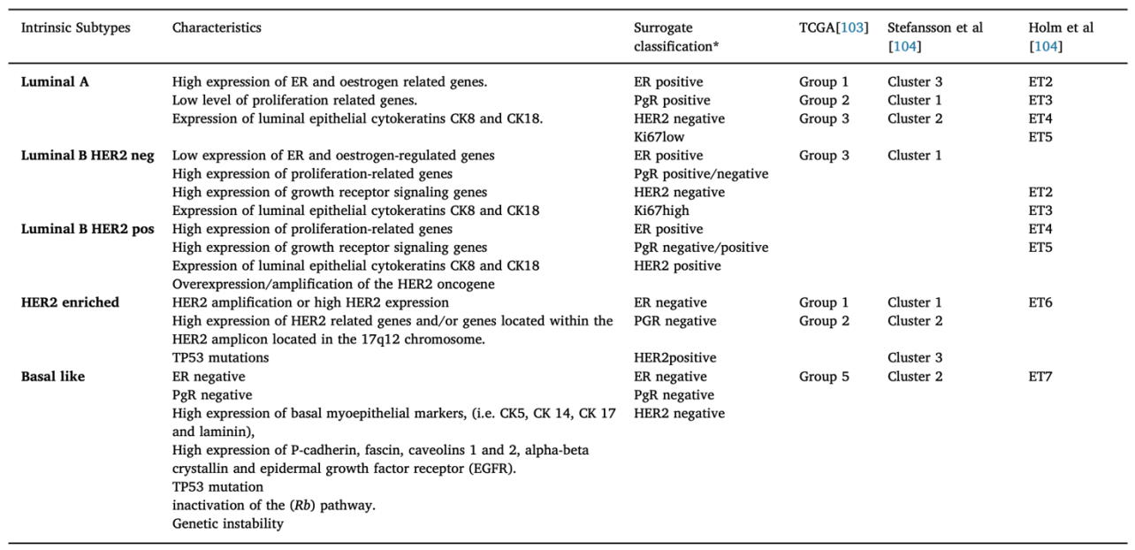
Table 1. Epigenetic-based subtypes of BC summarised by Pasculli et al. (2018).
For epigenetic-based subtyping, TCGA uses a comprehensive approach for subtyping BC, including DNA methylation data, while both Stefansson et al. (2015) and Holm et al. (2010) subtypes BC based on DNA methylation. Intrinsic subtypes are genetic-based (Perou et al., 2000), which have been widely recognised as the subtypes of BC and associated with many unique characteristics, as the Table shows. Surrogate classification is based on a combination of the routine pathological markers ER, PR, and HER2 and the proliferation marker Ki67 (Lundgren et al., 2019). 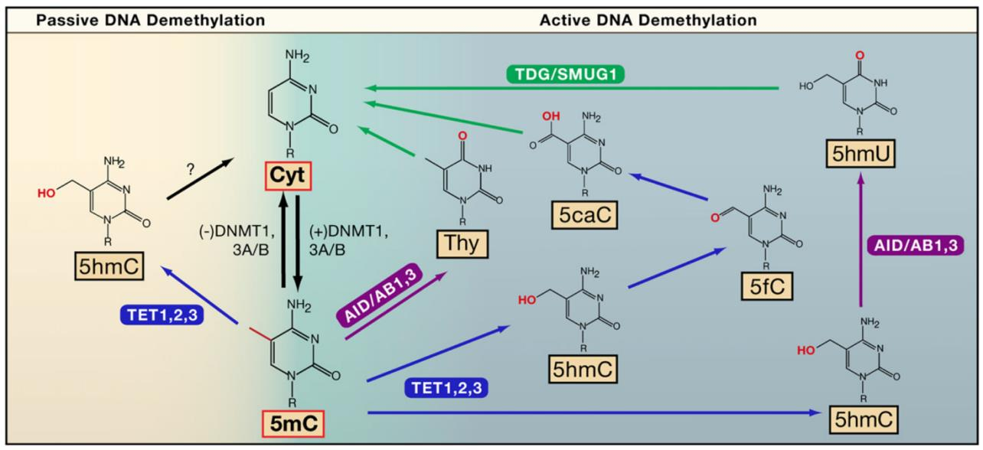
Figure 1. DNA demethylation pathways, according to Chekhun et al. (2007).
DNMT3A/B introduces de novo DNA methylation to specific gene sequences during development. The methylation is sustained by DNMT1, which can methylate unmethylated DNA strands during DNA replication. Due to the mutagenic property of cytosine, demethylation will happen spontaneously without the protection of CpG islands and DNMT1, which is the passive methylation pathway. Meanwhile, DNA repair actively demethylates DNA through different pathways, where TET enzymes and other enzymes are involved (Bhutani et al., 2011). Both active and passive demethylation contributes to the dynamics of DNA methylation, which can be a target for BC therapy, given the popularity of DNA methylation in BC.
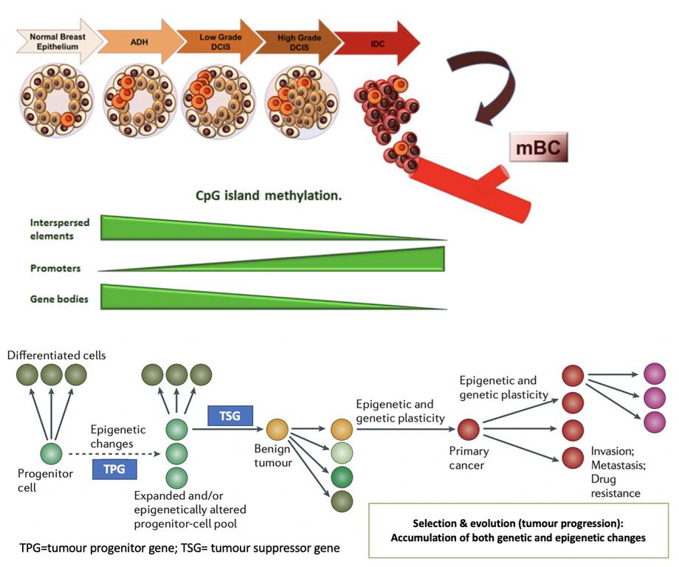
Figure 2. DNA methylation during BC progression and mechanistic explanation based on the epigenetic progenitor model. Adapted from Pasculli et al. (2018) and Feinberg et al. (2006).
Invasive ductal carcinoma (IDC) is the most common breast cancer type. Following cancer cells arising in normal breast epithelium, no-obliged pre-invasive lesions, termed Atypical Ductal Hyperplasia (ADH) and/or Ductal Carcinoma in situ (DCIS), are formed. The grade of the carcinoma progressively increases to finally result in metastasis. The process is accompanied by DNA methylation reprogramming, characterised by increased promoter region methylation and demethylation of gene bodies and repetitive sequences (Pasculli et al., 2018). According to the epigenetic progenitor model, these methylation alterations could accumulate before oncogenesis (Feinberg et al., 2006). Cancer can be regarded as a disease of cell division caused by dysregulated gene expression in a tumour-progenitor cell due to epigenetic changes. The alterations lead to tumourigenesis when there is a lack of tumour suppressor gene expression due to either genetic mutation or epigenetic silencing. The cells with the alteration will undergo selection due to instability caused by the alteration, which enhances the alteration with genetic and epigenetic plasticity, resulting in sequential changes in DNA methylation in favour of tumourigenesis and against antitumour drugs even if there are no genetic changes.

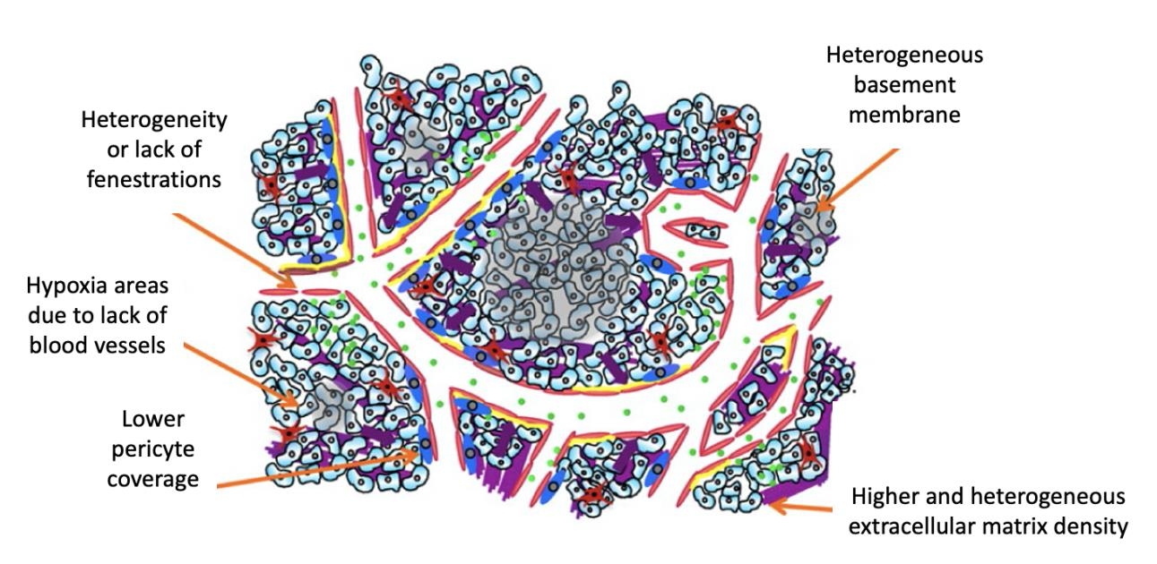
Figure 3. Characteristics of TME that stop drug uptake. Adapted from Danhier (2016).
These alterations contribute to a higher interstitial fluid pressure that reduces material exchange between blood and intercellular matrix, which disadvantages drug uptake and lowers drug efficacy. Blood vessel overgrowth in cancer often leads to increased retention of nano drugs in the tumour, but the effect is not significant in the solid human tumour due to these characteristics of TME. Therefore, active delivery of epi-drugs targeting tumour tissues, prolonged retention in tumour tissues, and continuous release of these drugs are essential for treating solid tumours like BC.

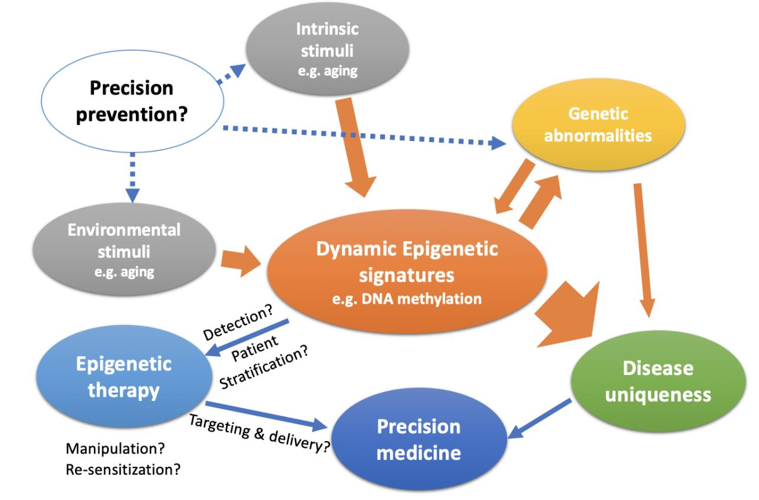
Figure 4. Graphic summary of how epigenetic therapy is related to precision medicine. Partly adapted from Liu (2012).
Dynamic epigenetic signatures translate both environmental and intrinsic stimuli and genetic abnormalities into disease uniqueness, requiring precision medicine. By detecting DNA methylation, we can stratify the patients according to their epigenetic traits and tailor the epigenetic therapies accordingly. As part of epigenetic therapy, epi-drugs are designed to reverse DNA methylation and/or re-sensitise traditional treatments such as chemo- and radiotherapy, which may need nanoparticle-based active drug delivery systems to increase efficacy by penetrating TME. With the development of techniques to detect and manipulate DNA methylation and an increased understanding of DNA methylation dynamics in tumourigenesis, early intervention according to DNA methylation profiles could enable BC prevention.

